6401010

CTS-WEEK-5

MICROSERVICES

Creating Microservices for account and loan

<https://start.spring.io/>

use this link to create your zip files as loan and account

by giving the following data as such

and even select your dependencies SPRING BOOT DEV TOOLS , SPRING WEB

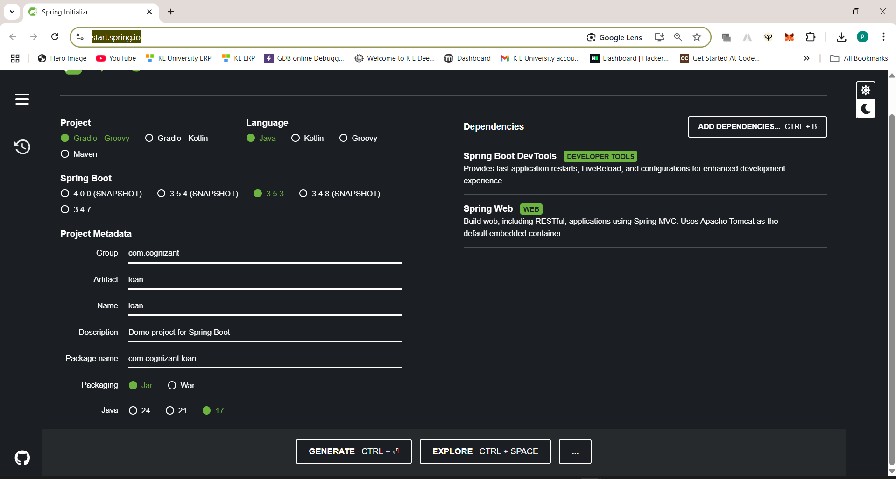

and then click on generate you will get your two files

now make a path in your folder   
D:\Koushik\CTS WEEK-5\Microservices_with_API_Gateway\Creating Microservices for account and loan\6401010\microservices

or what ever name you give

the two zip files which you get extract them and paste the in the above foaled location

next

create a controller foalder in the both account and loan as the paths below

1. D:\Koushik\CTS WEEK-5\Microservices_with_API_Gateway\Creating Microservices for account and loan\6401010\microservices\account\src\main\java\com\cognizant\account\controller

2. D:\Koushik\CTS WEEK-5\Microservices_with_API_Gateway\Creating Microservices for account and loan\6401010\microservices\loan\src\main\java\com\cognizant\loan\controller

Now create your controller.java files

Make sure that both the accounts and loan have pom.xml files in them

And open two terminals with the each path above and give this two commands in each

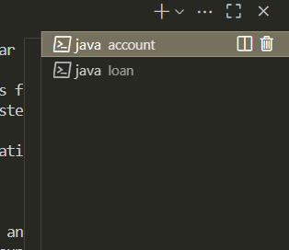

mvn clean install

mvn spring-boot:run

you will get to see your out put for accounts in this link

<http://localhost:8080/accounts/00987987973432>

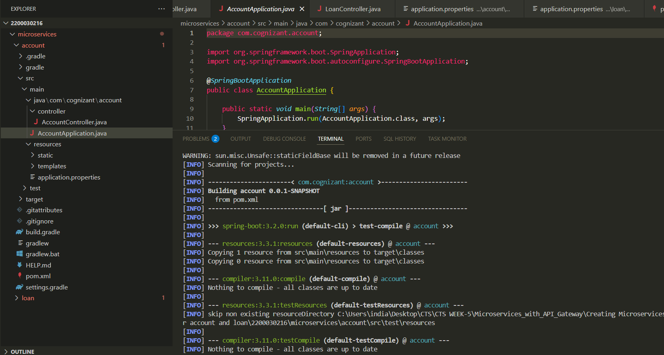

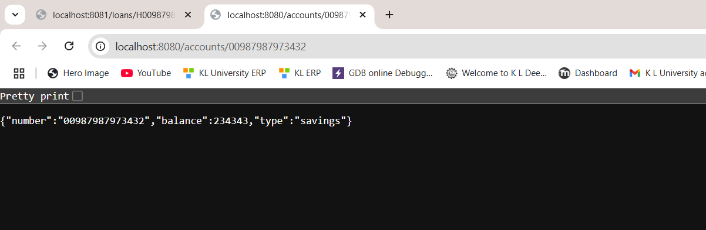

and for loans in this link

<http://localhost:8081/loans/H00987987972342>

